1) ALEXNET

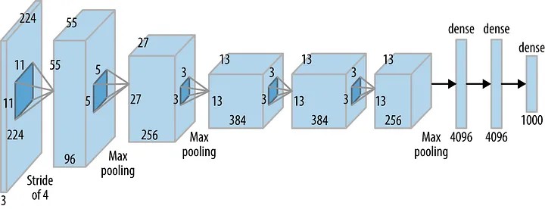
The network consists of 5 Convolutional (CONV) layers and 3 Fully Connected (FC) layers. The activation used is the Rectified Linear Unit (ReLU).
The convolution kernel sizes would be 11x11, 5x5, 3x3.
In order to avoid overfitting the alexnet model uses data augmentation and dropout layers.
Data Augementation-> the input data set is further expanded by cropping/ rotating/ tiliting the images in order to have more variety in the training data set.

Dropout-> Each node would have a 0.5 chance of being disabled during the training phase of a model.

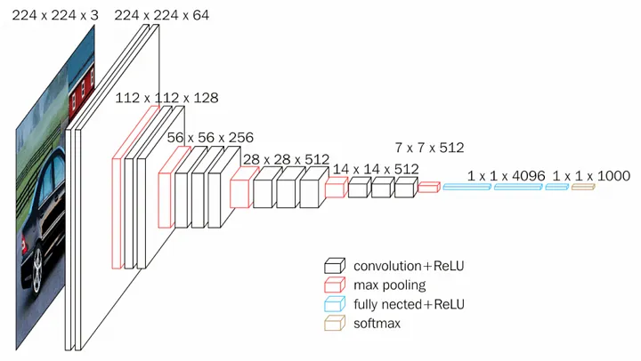
2)VGGNET

- This model was introduced in order to reduce the number of parameters in the convolution layers and to improve trainig time.
- All the conv kernels are of size 3x3 and maxpool kernels are of size 2x2 with a stride of two.
- The idea behind having fixed size kernels is that all the variable size convolutional kernels used in Alexnet (11x11, 5x5, 3x3) can be replicated by making use of multiple 3x3 kernels as building blocks.
3)RESNET
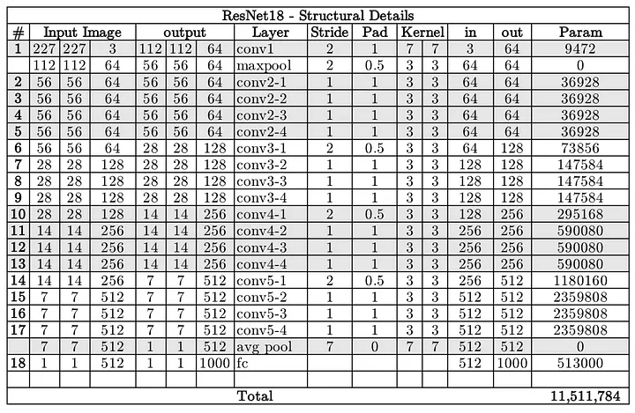
consists of multiple conv layers of filter size 3x3
Only two pooling layers are used throughout the network one at the beginning and the other at the end of the network.
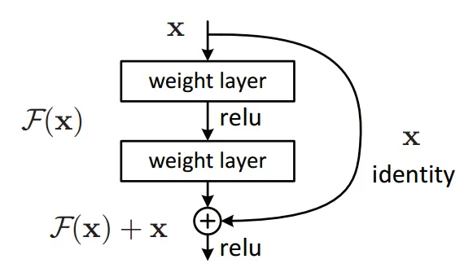
ResNet architecture makes use of shortcut connections to solve the vanishing gradient problem.

Instead of learning the mapping from x →F(x), the network learns the mapping from x → F(x)+G(x). When the dimension of the input x and output F(x) is the same, the function G(x) = x is an identity function and the shortcut connection is called Identity connection. The identical mapping is learned by zeroing out the weights in the intermediate layer during training since it's easier to zero out the weights than push them to one.
4)INCEPTION
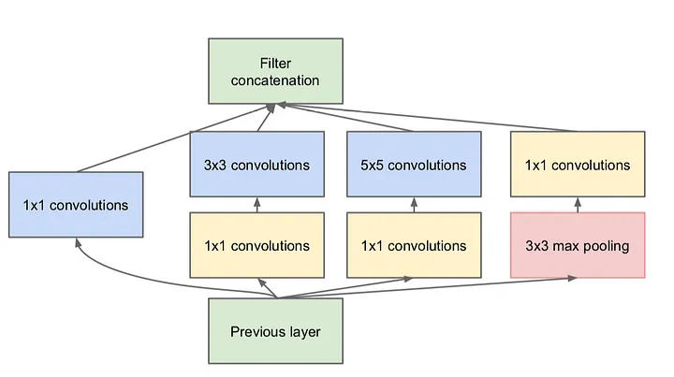
In an image classification task, the size of the salient feature can considerably vary within the image frame. Hence, deciding on a fixed kernel size is rather difficult. Lager kernels are preferred for more global features that are distributed over a large area of the image, on the other hand, smaller kernels provide good results in detecting area-specific features that are distributed across the image frame.
- Multiple kernels of different sizes are implemented within the same layer.
- Each inception module consists of four operations in parallel
1x1 conv layer
3x3 conv layer
5x5 conv layer
max pooling
- The 1x1 conv blocks shown in yellow are used for depth reduction
- The results from the four parallel operations are then concatenated depth-wise to form the Filter Concatenation block (in green).
- GoogleNet is a version of the Inception model.

